Registration Form
Please complete this form and e-mail (cundey@amgen.com) or fax (401-397-0760) attention to Cenk Undey. Registration deadline is August 19, 2011.

There are no registration fees for PPAR 2011. However, registration is required for on-site access (badges will be provided at the front desk located in admin building AR6). Due to limited space, registration is at the discretion of the Steering Committee.

Name: | Company:
Name Preferred on Identification Badge:
Phone: | Fax:
Administrative Support Person: | Admin. Phone:

Lodging
PPAR 2011 will have a block of rooms at the Crowne Plaza Hotel (801 Greenwich Avenue, Warwick, RI 02886) at a rate of $92.00 (plus tax) **first come-first serve**. Please make your own reservations and ask Amgen rate.
http://www.CrowneHotelWarwick.com (1 877 2 CROWNE (1 877 227 6963))

Activities

Yes, I will be able to attend the PPAR Roundtable ________

Please reserve a room for me at the Crowne Plaza Hotel ($92.00 plus tax):

Check In: _______________ Check Out: _______________ Number of nights: _____________

Sorry, I cannot make it this year ________

(please indicate your preference)
I will / will not attend :
Group Reception on the evening of Sep. 26th (6:00 – 9:00 pm)
(please indicate your preference)
I will / will not attend:
Group Dinner on the evening of Sep. 27th (6:00 – 10:00 p.m.; Location TBD)

Special Dietary Needs/Other Requirements:

Meeting objectives

In order to ensure active participation and mutually beneficial discussions for all attendees, the Steering Committee is requesting that attendees please provide a short paragraph regarding each of these questions. The answer of these questions will be used to determine agenda topics, discussion leads and potential areas of break-out sessions.

What two things do you most want to get out of this roundtable discussion?
What two things do you feel you could share during this roundtable discussion?

Directions / Transportation

The address of our site is:

40 Technology Way
West Greenwich, RI 02817

2A
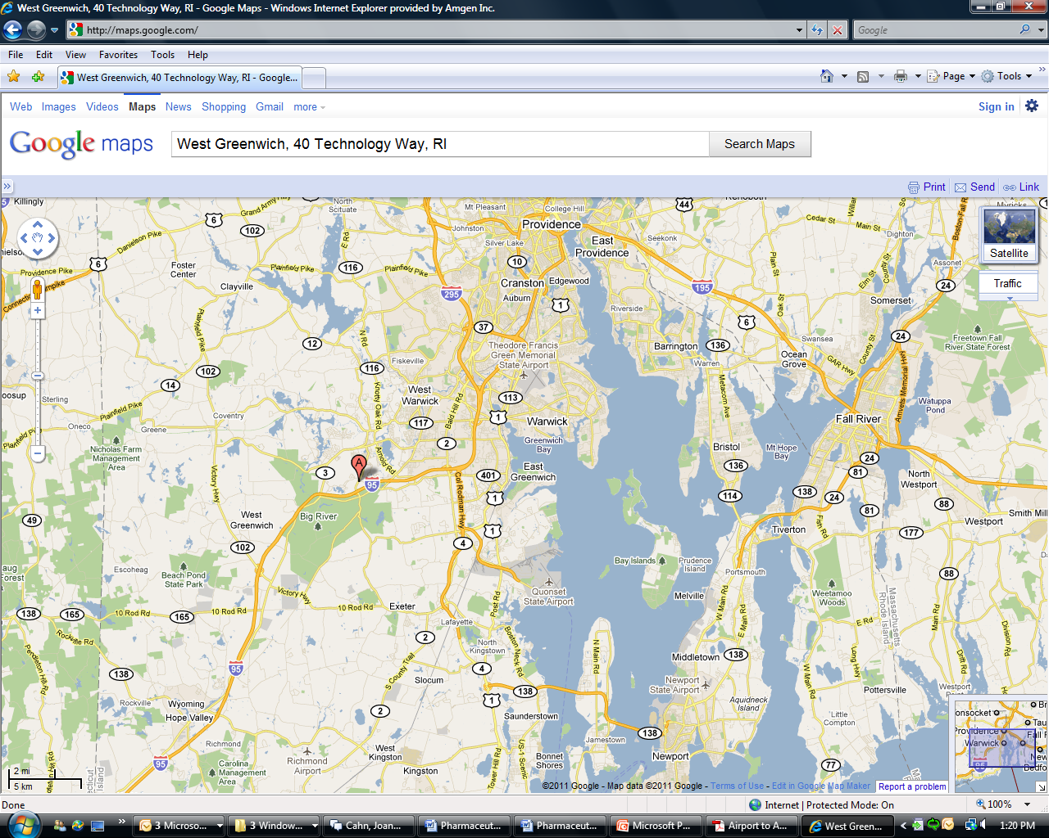

DIRECTIONS TO Amgen Rhode Island Site:

From Theodore Francis Green Airport Providence
- Head northeast on Airport Connector Road
- Slight right to stay on Airport Connector Road
- Keep left at the fork, follow signs for I-95 S/New York and merge onto I-95 S
- Take exit 6 A for Hopkins Hill Road
- Turn right onto Hopkins Hill Road
- Turn right at entrance for 40 Technology Way

From Crowne Plaza Hotel
- Head north on Greenwich Avenue toward Greenwood Avenue
- Turn left onto East Avenue
- Merge onto I-95 S via the ramp for New York
- Take exit 6A for Hopkins Hill Road
- Turn right onto Hopkins Hill Road
- Turn right at entrance for 40 Technology Way

